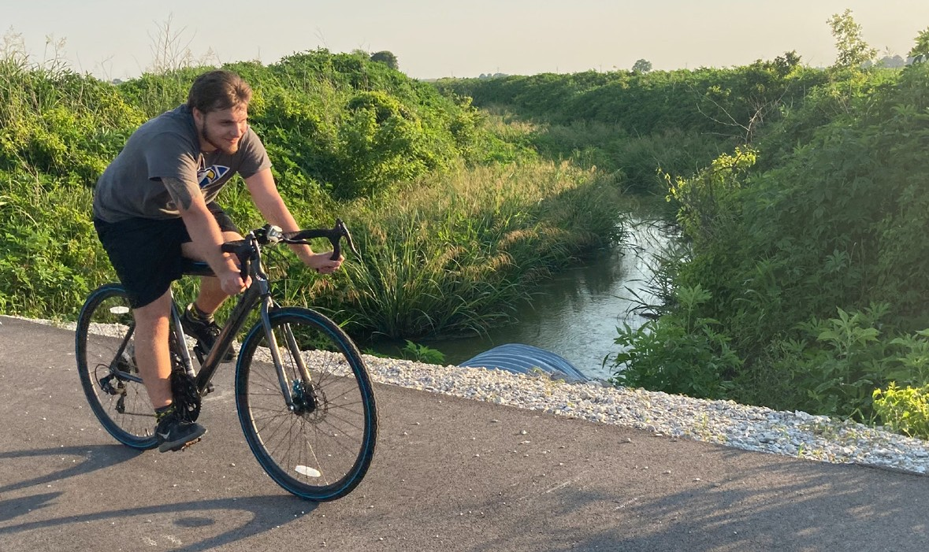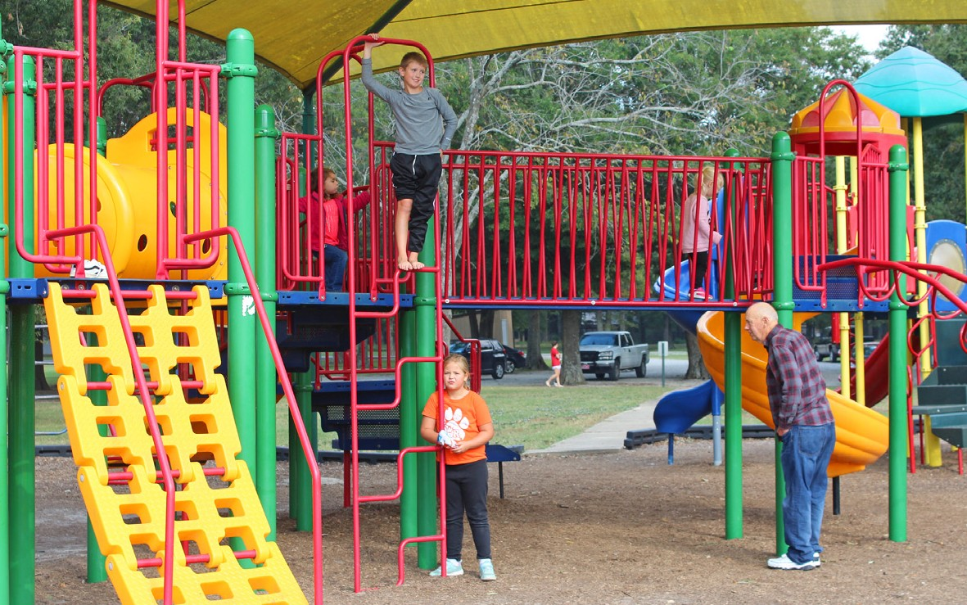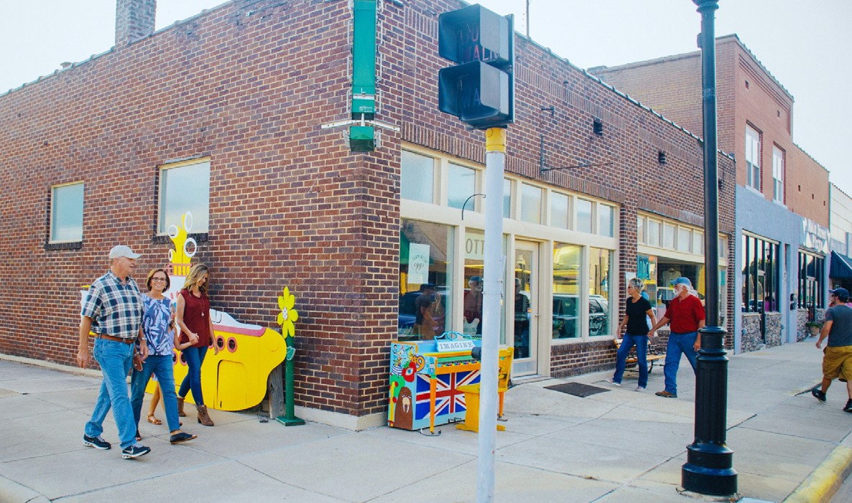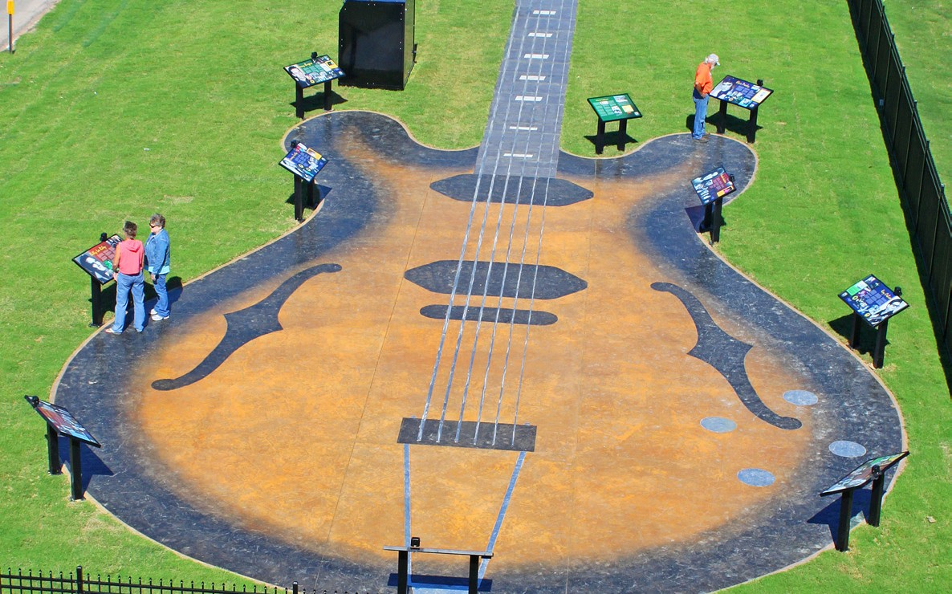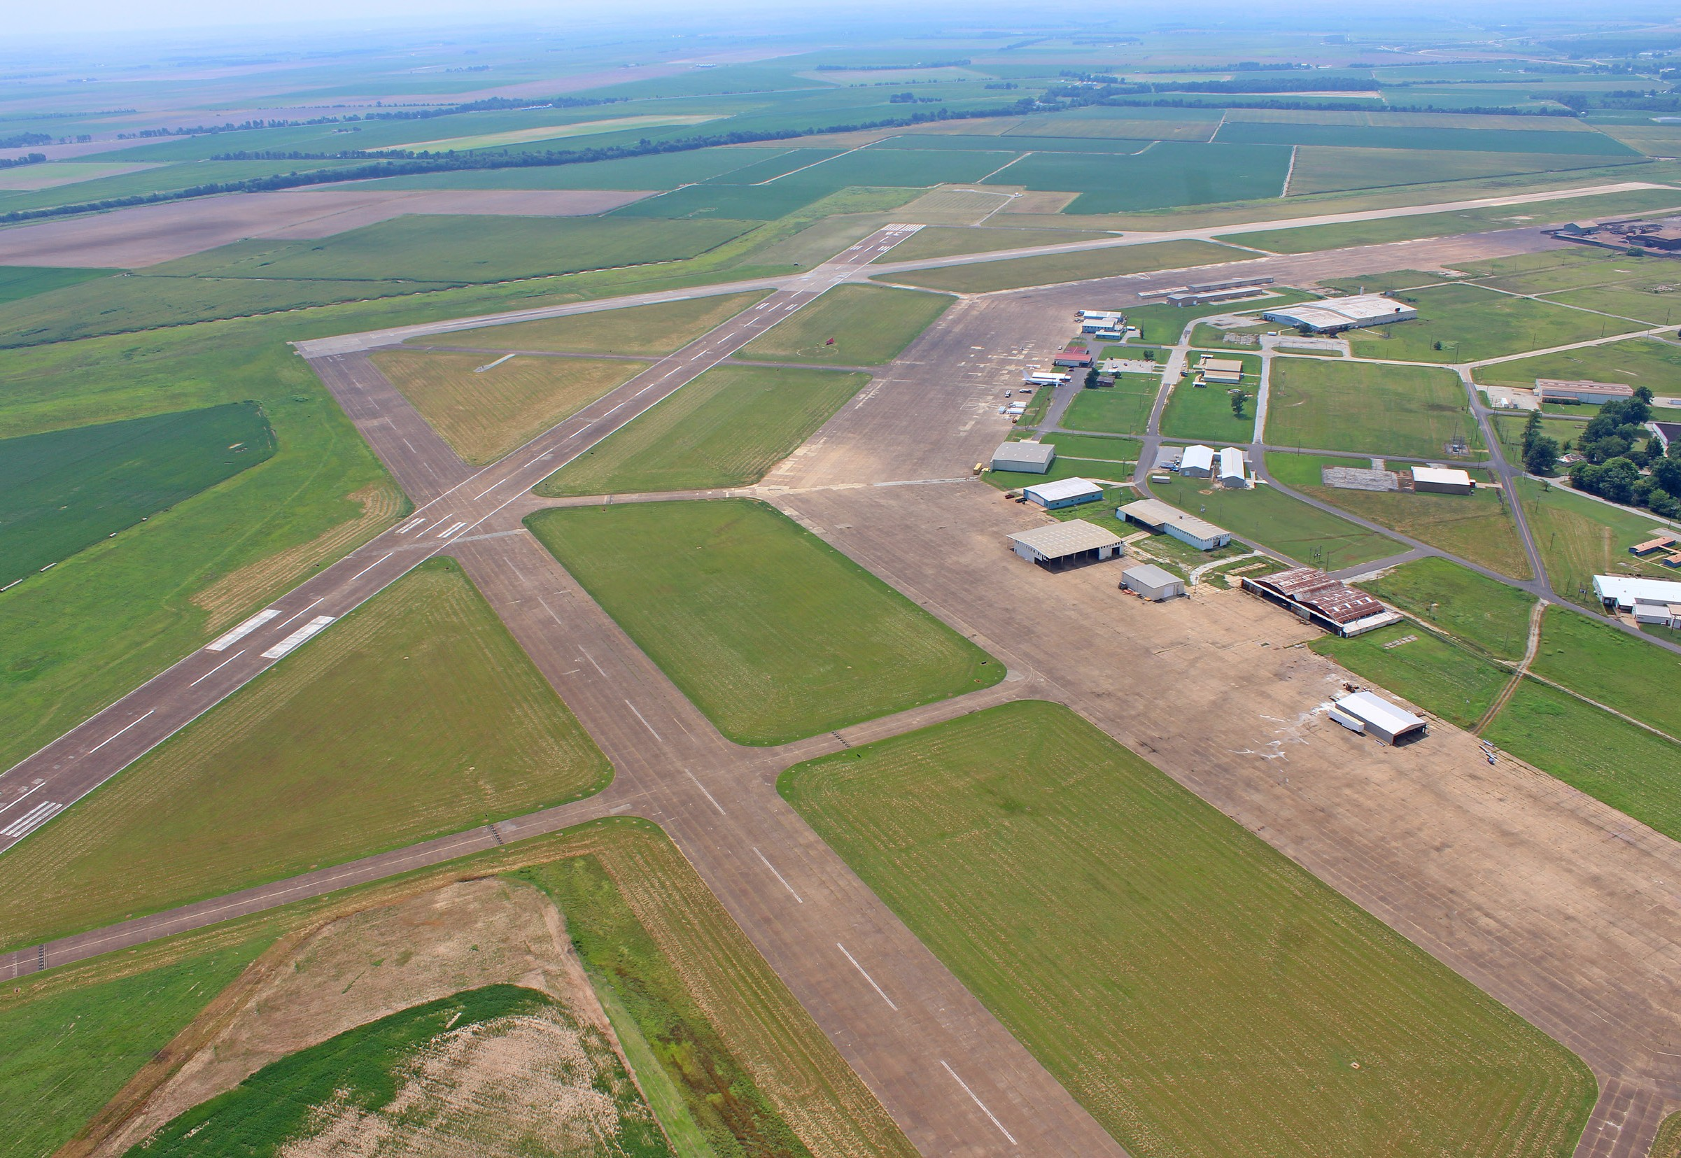
Lawrence County Rail-Trail
Stewart Park
Downtown Walnut Ridge
Guitar Walk
Walnut Ridge, Arkansas
Come Grow With Us
Walnut Ridge Regional Airport

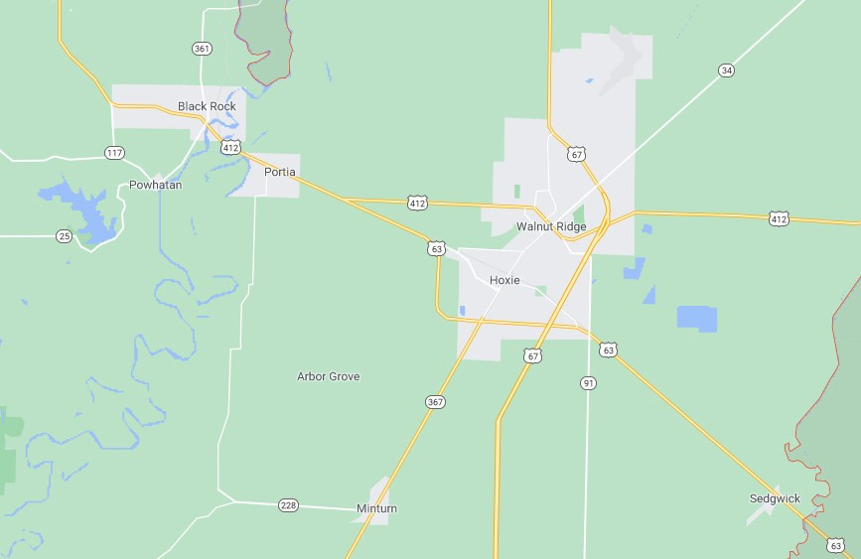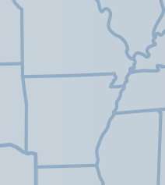Walnut Ridge: Live, Work, Enjoy
Hardy 39 miles
Pocahontas 14 miles
Williams Baptist University
Enrollment: 619
Resident Students: 422
WR Regional Airport Suitable for Large Aircraft 3 Reinforced Runways
Hwy 67
4-Lane to Pocahontas

Walnut Ridge Pop. 5,345
Lake Charles State Park
Powhatan Historic State Park
Hwy 412
4-Lane to Paragould
Nearing Completion Paragould
25 miles
Amtrak Station
Lawrence County Pop. 17,774
Hoxie Pop. 2,780
Hwy 67
Divided 4-Lane Freeway to Little Rock
Future
I-57
Future I-57 Federally Designated Will Connect Chicago to Little Rock
Newport 43 miles
Jonesboro 24 miles
Memphis
^{e} 93 miles
e
Walnut Ridge

e
Little Rock
130 miles
St. Louis e
219 miles
+

Business and industry today look beyond the bottom line. They want to locate where both their business and their people can

Stewart Park
Recreation

thrive. That’s where Walnut Ridge, Arkansas, comes in.

There is a reason Walnut Ridge is growing, and it goes beyond our ideal location. It’s a place where quality of life is valued. Schools and healthcare. Parks and trails. A place to feel safe. Family.
Community. People doing life together.

Transportation, access, and a growing market all make Walnut Ridge attractive. Our community makes it special. Walnut Ridge provides the amenities residents desire, along with the charm and safety of a small town.
- 70-acre city park includes multiple ball fields, swimming pool, playground, pavilions, fishing pond, walking trail, and bike trail. Recently acquired grant will fund $400,000 in additional park improvements.
- Largest summer sports program in the county. Summer baseball, softball, t-ball games are packed with spectators.
- Free Christmas light display attracts thousands of visitors.

Lawrence County Rail-Trail
- Fully paved 6.5 mile walking/biking trail extends all the way through Walnut Ridge, from WBU campus in the north to Hoxie in the south.

Beatles at the Ridge Festival
- Free music festival each September covers six city blocks and has become one of the fastest growing festivals in the South.
- Two stages of entertainment and over 100 vendors.

History

Location, Location, Location....
Walnut Ridge has what every business and industry desires:
Walnut Ridge Market Area
Incorporated Area (Cities): 9,681 Unincorporated Area: 3,250
WBU Campus Housing: 422 (Total Enrollment: 619)
Total Market Population: 13,353

Market defined as areas of Lawrence County within a 20-minute drive of
Walnut Ridge.
Figures based on 2010 US Census data and WBU fall 2020 enrollment.

K-12 Schools

Education
Beatles Park
- Massive, 20’ X 10’ sculpture in downtown Walnut Ridge recalls the Fab Four’s 1964 stop at Walnut Ridge Airport.
Guitar Walk at Cavenaugh Park
- A 115’ walk in the shape of an Epiphone Casino guitar honors rockabilly legends who once frequented the area.
- 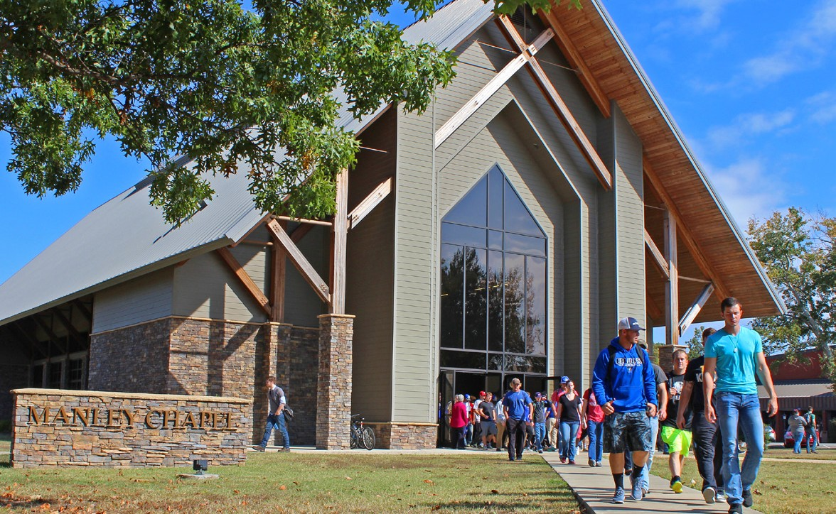Visual displays and audio tour pay tribute to Elvis Presley, Johnny Cash, Jerry Lee Lewis, Carl Perkins, and several others
Williams Baptist University

an ideal location. Retailers find a strong and growing market base, while industries find a centrally located community with outstanding access to air, road, and rail transportation.

The Walnut Ridge retail market has more than 13,000 residents, most of whom live within the city limits of Walnut Ridge or the adjoining city of Hoxie. The market is further enhanced by Williams Baptist University and its enrollment of over 600,
including approximately 75 percent (more than 400 students) who reside on the Walnut Ridge campus nine months out of the year.

Ideally situated in northeast Arkansas, Walnut Ridge provides convenient proximity to metropolitan areas such as Memphis, Little Rock, and St. Louis.

And the city’s strongest suit is its abundant access to transportation.

Walnut Ridge Regional Airport
- Three reinforced concrete runways (one 6,000’ and two 5,000’ runways).
- Handles aircraft of all sizes, including large jetliners.
- Adjoined by spacious industrial park.

Highways
- Future I-57: Federally designated corridor will follow existing US 67 freeway from Little Rock to Walnut Ridge. New alignment will link Walnut Ridge to Poplar Bluff, Mo. Completed I-57 will connect Chicago to Little Rock.
- US Hwy. 67: Four-lane, divided freeway to Little Rock.
- US Hwy. 63: Four-lane connection to Jonesboro and I-555.
- US Hwy. 412: Four-lane connection to Paragould nearing completion.

Railways
- Served by intersecting Union Pacific and BNSF lines.
- Popular stop for Amtrak Texas Eagle passenger train.
- Walnut Ridge and Hoxie school districts have a combined enrollment of 2,160 students.
- Safe and caring learning environment.
- School drop-off and pick-up, as well as bus service.
- Wide array of sports programs, band, and other extracurricular activities.

Higher Education
- Williams Baptist University is a private, liberal arts university in Walnut Ridge, founded in 1941.
- Over 25 majors. Most popular: Biology/Pre-Med, Business, Education, Psychology, Christian Ministries.
- 18 varsity and 3 junior varsity athletic teams.
- Williams Works: Innovative initiative allows students to work in exchange for their cost of education.
Healthcare
- Lawrence Memorial Hospital is a 25-bed critical access hospital in Walnut Ridge.
- Full-service laboratory, radiology department, and 24-hour emergency department.
- Speciality clinic and new MRI facility.
who shaped early rock-and-roll music.
- Located next to Iron Mtn. Depot in downtown Walnut Ridge.

Wings of Honor WWII Museum
- Truly impressive collection of World War II artifacts and displays at Walnut Ridge Regional Airport.
- Recalls the bustling days of the Walnut Ridge Army Flying School, which trained over 4,000 pilots in WWII.
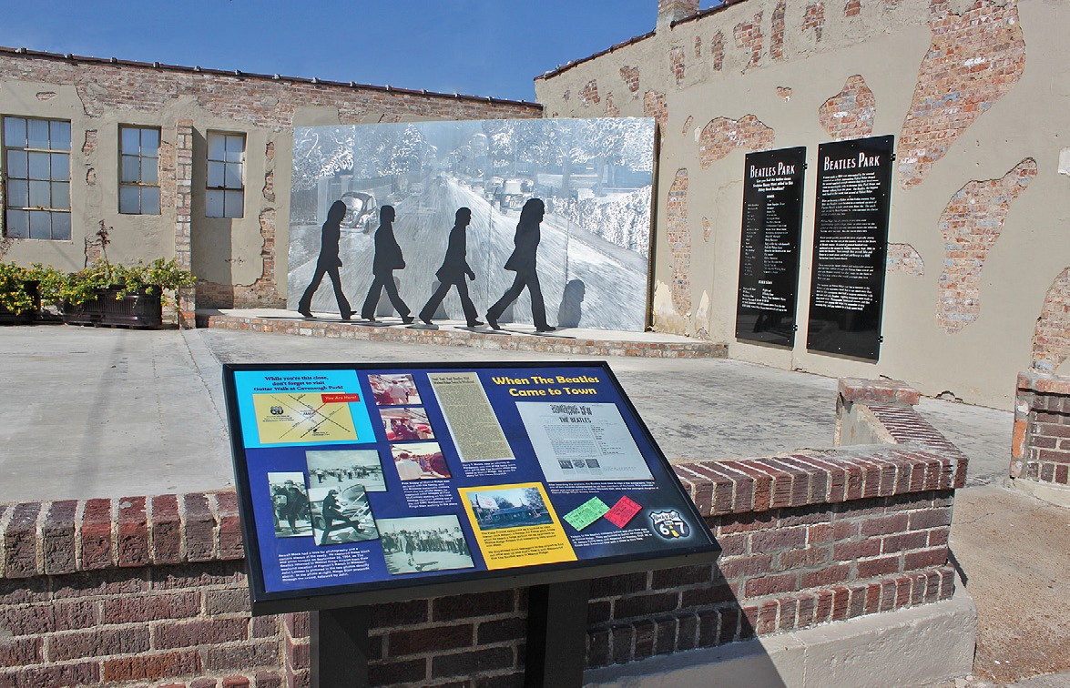
Beatles Park

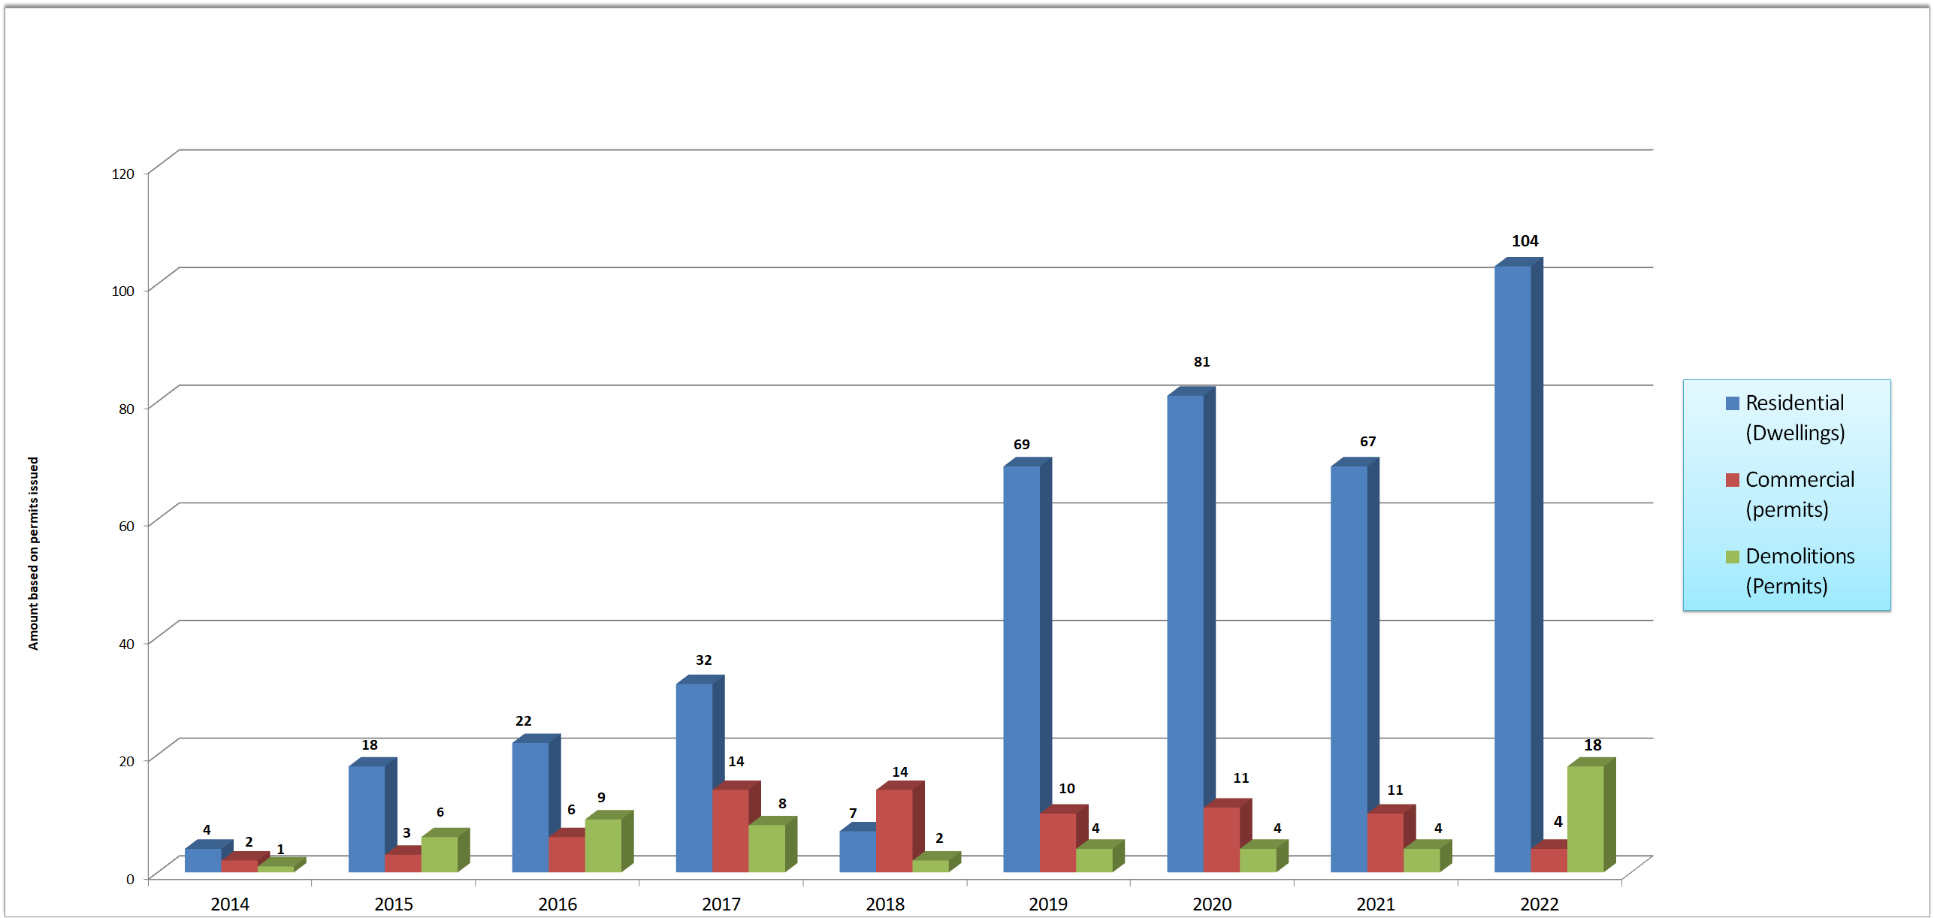
Walnut Ridge Growth Chart
Permits Issued 2014 - 2022
Residential & Commercial Construction, Demolitions

Walnut Ridge Rankings
State of Arkansas
(HomeSnacks.com)

#4 Most Affordable Places to Live #3 Best Places to Buy a Home #7 Safest Places to Live

Most Musical City in Arkansas (OnlyInYourState.com/Arkansas)

Population Growth
2010 Census: 4,890
2020 Census: 5,482
Increase: 0.90% annually

City Facts & Figures
Walnut Ridge Taxes & Infrastructure
Property Taxes: 45.30 Millage Fire Rating: ISO 3
Potable Water: Currently at 40% total capacity Sewer Facilities: Currently at 30% capacity
New Sewer Treatment Plant: Construction begins in 2021

Estimated Income (2022)
Median Household Income: $50,776 Average Household Income: $57,337 Estimated per capita income: $20,509

Estimated Home Value (2022)
Median Value: $81,448 Average Value: $143,000

Contact Info
CityofWalnutRidge.com • DowntownWalnutRidge.org • LawCoChamber.org

Walnut Ridge City Hall Mayor Charles Snapp 300 W. Main
Walnut Ridge, AR 72476

cityhall@cityofwalnutRidge.com • (870) 886-6638
Lawrence County Chamber of Commerce
Rachel King
P.O. Box 842
Walnut Ridge, AR 72476

rachelking.lcchamber@gmail.com • (870) 886-3232

